PowerMatcher
Communication Protocol Specification
Authors:
Aldo Eisma (IBM), Frens Jan Rumph (TNO)
Release: 0.7
Revision: 7
Date: 5-3-2013





- Table of Contents
1 Introduction 5
1.1 Identification 5
1.2 Background 5
1.3 Purpose and scope 5
1.4 Intended Audience 5
2 PowerMatcher architecture concepts 6
2.1 Matcher and agent roles 6
2.2 Auctioneer, Concentrator and Device Agent roles 7
2.3 Bids, prices and market basis concepts 7
2.4 Prices and market basis encoding 8
2.5 Bid encoding 8
3 PowerMatcher applications and protocol stack 10
3.1 PowerMatcher Information Protocol 10
3.2 Information Transport Protocol 10
3.3 Protocols on the Network Layers 10
4 PowerMatcher Information Protocol - Common specification 11
4.1 Messages 11
4.2 Normal interaction 11
4.3 Market basis mapping 12
4.4 Addressing 12
4.5 Initiation and termination 12
4.6 Fall back and recovery 12
4.7 Error handling 12
4.8 Timing constraints 13
4.9 Security 13
5 PowerMatcher Information Protocol - Broadband specification 14
5.1 Message syntax and message encoding 14
5.2 Initiation and termination 16
5.3 Fall back and recovery 16
5.4 Error detection and handling 16
5.5 Security 16
5.6 Timing constraints 16
6 PowerMatcher Information Protocol - Narrowband specification 17
6.1 Message syntax and message encoding 17
6.2 Market basis mapping 18
6.3 Initiation and termination 18
6.4 Fall back and recovery 18
6.5 Error detection and handling 19
6.6 Security 19
6.7 Timing constraints 19
7 References 20

Figures
Figure 1 - Example PowerMatcher agent cluster 6
Figure 2 - Matcher and agent roles 7
Figure 3 – Auctioneer, concentrator and device agent roles 7
Figure 4 - Price, price step and NPU example 8
Figure 5 - Bid line curve example 8
Figure 6 - Protocol stack 10
Figure 7 – PowerMatcher interactions between agent and matcher 11
Figure 8 – Agent participation state diagrams (from the agent and matcher perspectives) 12

Tables
Table 1 - Message header specification (Broadband PowerMatcher Information Protocol) 14
Table 2 - Price update message (Broadband PowerMatcher Information Protocol) 15
Table 3 - Bid update message (Broadband PowerMatcher Information Protocol) 15
Table 4 - Bid update message – price points (Broadband PowerMatcher Information Protocol) 15
Table 5 - Bid update message – demand array (Broadband PowerMatcher Information Protocol) 15
Table 6 - Message header specification (Narrowband PowerMatcher Information Protocol) 17
Table 7 - Price update message (Narrowband PowerMatcher Information Protocol) 17
Table 8 - Bid update message (Narrowband PowerMatcher Information Protocol) 18
Table 9 - Market basis mapping 18

Version History
Revision | Description | Author
1 | Initial (incomplete) draft | A.H. Eisma (IBM)
2 | Completed draft | A.H. Eisma (IBM)
3 | Revised and commented draft | F.J. Rumph (TNO)
4 | Narrowed scope for delivery in accordance to project plan, added introduction on PowerMatcher roles, revised protocol stack description, and performed editorial changes. | F.J. Rumph (TNO)
5 | Added missing field for significance in market basis. | A.H. Eisma (IBM)
6 | Updated layout and logo. | A.H. Eisma (IBM)
7 | Minor corrections to the scope description. | A.H. Eisma (IBM)

Introduction

Identification
The full identification of this document is: “PowerMatcher - Communication Protocol Specification”.

Background
The PowerMatcher reference implementation is a component-based implementation in Java of the PowerMatcher concept. Release 0.7 serves as an intermediate step between the original PowerMatcher 3.0 implementation in .NET by ECN towards a 1.0 release of the reference implementation of PowerMatcher in Java. The PowerMatcher reference implementation and its communication protocols provides the basis for this document.

Purpose and scope
This document contains the technical specification for communication protocols used in information exchange within PowerMatcher based systems. The document specifies a PowerMatcher information protocol for use in wideband and narrowband communication systems. This specification is intended to be implementation independent and the specification implemented by the PowerMatcher reference implementation. In future versions of this document, specifications will be provided on how the

Intended Audience
This technical specification is intended for development and implementation of systems intended to be operated in PowerMatcher environments.

PowerMatcher architecture concepts
PowerMatcher is a concept for distributed for supply and demand management which uses a real-time agent-based electronic market based approach. In the PowerMatcher concept, (flexibility) in supply and demand is expressed in bids sent to a market. Based on these bids a market price is determined which creates either a balance between supply and demand (the equilibrium) or a market price which achieves some other objective.
The bids are provided by agents who represent the interests of particular devices and their users; e.g. home appliances, HVAC equipment, generators, electric vehicles, storage, etc. The bids express the ‘willingness’ to consume or produce over a price range. Each time this willingness changes, new bids are emitted by these agents. E.g. the price point for which a heat pump will consume may be raised when the temperature drops and the ‘urgency’ for the heat pump to supply heat and consume electricity increases.
An auctioneer receives these bids and determines a price for which supply will equal demand. This price is distributed to all the agents who then act according to their bid in combination with the price; i.e. the agent will control the device such that the supply/demand in the bid for the market price is realized.
The exchange of bids and prices may be aided by distributed concentrator agents. These agents receive bids which are concentrated and then sent onwards to an auctioneer or to another concentrator. The distribution of price follows the same path from auctioneer through concentrators back to the agents. I.e. the real time market has a hierarchical structure. An example of this structure is visualized in Figure 1
The concept of a real time market may be used to create an equilibrium between supply and demand, e.g. to operate a microgrid. However, also other objectives may be desirable. An objective agent may bid into the market to connect to an external objective, e.g. to ensure that a cluster of devices follows an imbalance signal from a e.g. transmission system operator. Furthermore, specialized concentrators may ensure that certain constraints are met or objectives are achieved for a certain part of a total real time auction.
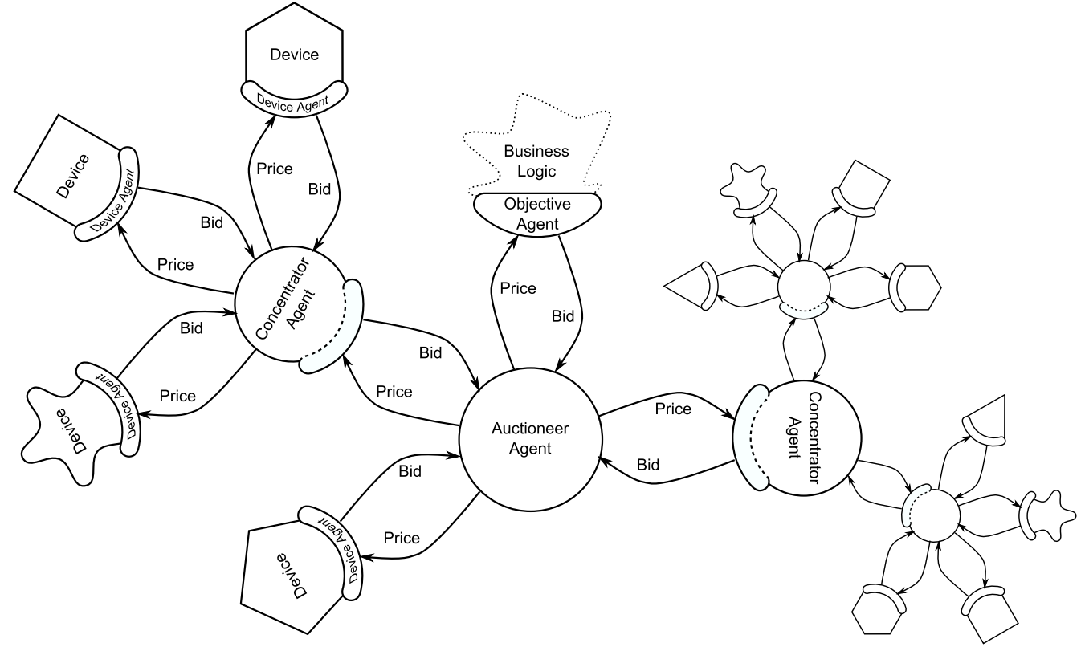
Figure 1 - Example PowerMatcher agent cluster

Matcher and agent roles
The interactions in PowerMatcher based systems can be viewed to exist between application (components) which take the following roles:
the agent role determines bids based on flexibility in supply and/or demand and sends these bids to the matcher its associated with; each new bid replaces or updates the previous bid of the agent;
or the matcher role receives bids and sends price information towards the agents its associated with; the price sent remains the current price until a new price is sent.
In principle any agent is associated to exactly one matcher, and any number of agents may be associated with one matcher. These roles and their relationship are visualized in Figure 2.

Figure 2 - Matcher and agent roles

Auctioneer, Concentrator and Device Agent roles
Additionally a number of more specific roles are identified which relate to the location of a PowerMatcher market participant in a PowerMatcher hierarchy:
the auctioneer role the root matcher in a PowerMatcher hierarchy, responsible for setting the market price for the hierarchy;
the concentrator role a ‘interior’ node in a PowerMatcher hierarchy which concentrates bids received from agents further down the hierarchy (in the role of matcher), and represents all lower agents towards a node higher in the hierarchy; the price updates received by concentrators are sent down to the associated agents lower in the hierarchy;
and the device agent role the leaf nodes in a PowerMatcher hierarchy which represent the specific needs and possibilities of a device and its users.
Figure 3 visualizes these three roles, how they are associated and the relationship with the matcher and agent roles. Note that with these roles, hierarchies of in principle unlimited depth can be constructed, although only three levels are shown in the figure below. Furthermore, hierarchies of just two levels are equally possible.

Figure 3 – Auctioneer, concentrator and device agent roles

Bids, prices and market basis concepts
As indicated, bids and prices are the main pieces of information exchanged in PowerMatcher based systems. In the context of the PowerMatcher concept and this document, they are defined as:
bid an expression of an agent’s intended instant demand and/or supply as a non-ascending function of the price (of the market); the demand / supply is in terms of e.g. power (in e.g. Watts) in case of electricity;
price the price as monetary amount to be paid by agents for demand (or paid to agents in case of supply) per volume of demand / supply; e.g. in terms of kilowatt-hours in case of electricity.
In order to successfully operate an electronic market such as the PowerMatcher, the participating agents must use some conventions, known in PowerMatcher as:
market basis it covers the commodity traded, the currency, minimum and maximum prices, the maximum significance of prices, and the number of ‘price steps’.

Prices and market basis encoding
Prices in PowerMatcher systems are expressed either as decimal values (floating point numbers) or as an integer, with either of the following two meanings:
- As price step, starting at index 0 for the minimum price.
- As normalized price unit, with an index of 0 for the price closest to 0.0
This is shown in the following example.
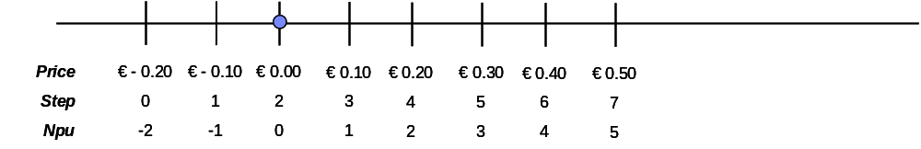
Figure 4 - Price, price step and NPU example
The minimum price is counted as the first price step, the maximum price as the last. So, for example if the minimum price is € -0,20, the maximum price is € 0,50, the price step is € 0,10, then the number of price steps is 8.

Bid encoding
A bid specifies the positive or negative demand over a price range, in a non-ascending bid curve. There are two ways to express bids specified in this document:
- The demand as vector with floating point value for each price step between minimum and maximum price as defined by the market basis.
- As a line curve define by price points connected with straight line segments.
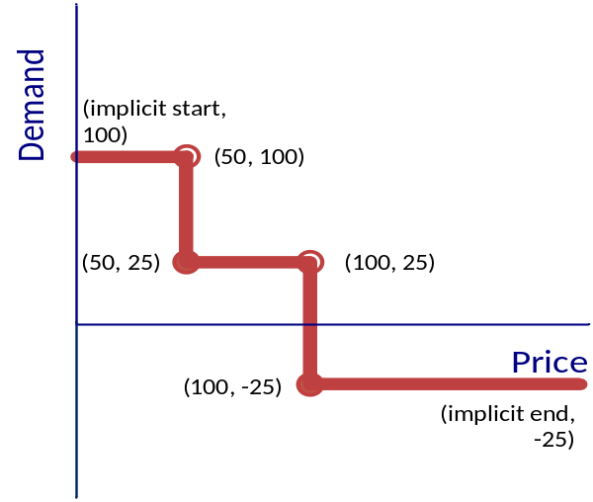
Figure 5 - Bid line curve example
The above example a bid curve is show that defines a bid curve with 2 price steps defined by 4 points:
Point | Price | Demand
0 | 50 | 100
1 | 50 | 25
2 | 100 | 25
3 | 100 | -25
- Note that price 50 and price 100 are used twice to define a price step using line curve semantics.
- The demand at price >= 100 is -25.
- The demand at price < 50 is +100.
Note that a flat bid curve can be represented by a single demand point where the price is any value in the range of the market basis.
The line curve representation can be converted to a vector representation and back. The conversion is lossless and is performed according to the following rules.
- From curve to vector, the demand at each price step is calculated as the intersection with the price and the line segment connecting the two points around the price.
- From vector to curve, the points are calculated for the smallest number of line segments that are an exact fit through the demand points.
- Steps in the demand vector, as in Figure 5 - Bid line curve example are identified and correctly represented in the line curve in order to preserve step semantics between conversions.
In a future specification the conversion from vector to curve and vector to vector (in the case of aggregation) may be lossy, for example limited by significance or by a maximum for the number of price points.

PowerMatcher applications and protocol stack
A PowerMatcher system consists of software agents that communicate bid and price updates as described in section 3. The communication between agents in PowerMatcher systems is based on a layered model, as shown in Figure 6.

Figure 6 - Protocol stack

PowerMatcher Information Protocol
PowerMatcher Agents interact by exchanging information per the PowerMatcher Information Protocol, which in terms of the IETF IP suite’s terms is on the application layer. This protocol provides the syntax for expressing the information of which the semantics are defined in 3.3.
The PowerMatcher Information Protocol is specified in this document in two variants: one optimized for rich information expression to be used in broadband networks, and one optimized for narrowband networks which is reduced in the amount of information which can be expressed (in particular in the bid updates). The latter is based on the NXP PowerMatcher for the HAN protocol rev. 6, see [1].

Information Transport Protocol
The units of information exchange (messages) in the PowerMatcher Information Protocol need to be transported between PowerMatcher software applications. Specifications of this/these protocol(s) is outside the scope of this version of this document.

Protocols on the Network Layers
Specifications of (the mapping to) protocols on the various network layers, such as transport, network and link layers in terms of IETF’s IP suite), is outside the scope of this version of this document.

PowerMatcher Information Protocol - Common specification
The PowerMatcher information protocol specifies the encoding of bid, price and market basis update to be used in information exchange between matchers and agents in PowerMatcher systems. The PowerMatcher information protocol has the following characteristics:
- The matcher sends updates of the market basis and market price to the Agents that are below the matcher in the PowerMatcher hierarchy. This is the normal interaction that is covered in the next section.
- The Agents sends bid updates to their parent matcher in the hierarchy.
- A bid is always in relation to the latest market basis received by the agent.
- Communication can be intermittent, guaranteed delivery is not assumed.
- Information exchange may be performed through connectionless networking.
- An agent becomes aware of its matcher as soon as it receives a market basis update.
- A matcher becomes aware of an agent as soon as it receives a bid update.
- Agent and matcher forget about each other if no updates have received with some agreed upon interval.

Messages
The PowerMatcher information protocol defines two messages.
- Price update (including a market basis update)
- Bid update

Normal interaction
The sequence diagram of Figure 7 defines the normal asynchronous interaction between the PowerMatcher agent and matcher roles.

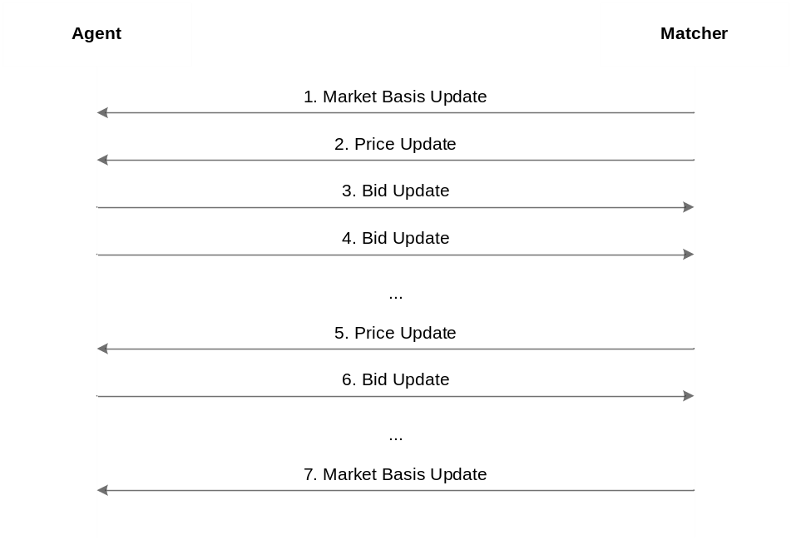
Figure 7 – PowerMatcher interactions between agent and matcher

Market basis mapping
It is possible that a matcher receives a bid for a market basis other than the latest. For example, when bid and market basis updates cross one another. In this situation the matcher transforms the bid to the current market basis.

Addressing
Addressing of agents and matchers is not specified in the PowerMatcher information protocol. Addressing and routing messages must be implemented on lower network layers for use by PowerMatcher applications.

Initiation and termination
The following cases must be observed for initiation and termination:
- The agent waits with sending its first bid until it has received a market basis from its matcher. The matcher broadcasts its market basis on a regular (configurable) interval, or whenever the market basis changes.
- A new agent is known to the matcher as soon as a matcher receives the first bid from an agent.
- A matcher ignores bids until it has been configured with or received its initial market basis.
- An agent or matcher may terminate and cease sending bids at any time.

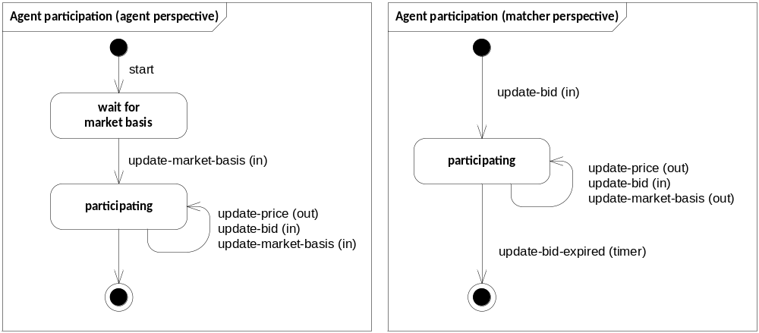
Figure 8 – Agent participation state diagrams (from the agent and matcher perspectives)

Fall back and recovery
- A matcher discards the last bid from an agent if the matcher has not received an unchanged or updated bid from the agent for some configurable interval. At this point the agent is no longer known to the matcher until the matcher received a new bid from the agent again.
- An agent may discard the market basis and market price if the agent has not received an unchanged or updated market basis for some (configurable) time. The agent’s behaviour in this case is outside the scope of this document.

Error handling
- When a matcher receives a bid for an unknown market basis, the bid must be ignored.
- When a matcher receives an invalid bid, the bid is ignored. A bid is considered invalid when the points in the bid curve are ascending.

Timing constraints
Messages can be sent in any sequence, at any frequency, and in any order. Messages can be sent and received at the same time.

Security
Message integrity, authenticity, confidentiality and non-repudiation are not defined in the PowerMatcher information protocol.

PowerMatcher Information Protocol - Broadband specification
The broadband PowerMatcher information protocol specified in this section is optimized for rich information expression to be used in broadband networks. It was developed by IBM and is supported by this release of the PowerMatcher reference implementation.

Message syntax and message encoding
The messages of the broadband PowerMatcher information protocol are variable-length binary encoded messages. The byte order is big endian (most significant byte first).
- An utf-8 string is encoded as a 2-byte unsigned integer specifying the length in bytes of the encoded data, followed by the Modified UTF-8 encoded data for the string.
- A 4-byte floating point value is encoded according to the IEEE 754 floating-point “single format” bit layout.

Message header
The following table specifies the header of the messages exchanged with the broadband PowerMatcher information protocol.
Field | Size in bytes | Type | Description
protocol id | 4 | unsigned integer | Magic value to identify this protocol, 0x504D494E (“PMIN “).
version | 1 | unsigned integer | Denotes the version of the protocol to which this message adheres. Version = 1 for this protocol.
msg type | 1 | unsigned integer | The message type; 1 for a price update message, 2 for the bid update message.
message contents
Table 1 - Message header specification (Broadband PowerMatcher Information Protocol)

Price update message specification
The new market price is communicated via the price update message that is sent by the matcher to the associated agents. This message contains the new market price and the corresponding market basis. The following table defines the message structure.

Field | Size in bytes | Type | Description
message header
commodity | >= 2 | utf-8 string | Commodity of the market basis, “electricity” for electricity.
currency | >= 2 | utf-8 string | ISO-4217 standard representation of the currency for the market basis, for example “EUR”.
price steps | 2 | signed integer > 0 | Number of price steps in the market basis range
minimum price | 4 | floating point | Minimum price in the price range of the market basis.
maximum price | 4 | floating point | Maximum price in the price range of the market basis.
market reference | 1 | unsigned integer | Wrapping sequence number for the market basis.
significance | 1 | unsigned integer | The number of significant digits in the market price, 0 = undefined.
current price | 4 | floating point | The current market price in normalized price units (npu).
Table 2 - Price update message (Broadband PowerMatcher Information Protocol)

Bid update message specification
The bid update message is a message from the agent to the matcher containing a bid curve, expressing the need for the electricity represented in a normalized bid price and the power demand quantity. The following tables defines the message structure.

Field | Size in bytes | Type | Description
message header
market reference | 1 | unsigned integer | Reference to a market basis sequence number received in the price update message.
bid number | 4 | signed integer >= 0 | Sequence number for the bid, starting at 0. The sequence number may wrap between 0 and an arbitrary maximum value.
bid encoding | 2 | signed integer > 0 | 0 = no bid; this is a keep-alive message without a bid update. In this case this field is the last field in the message.  1 = price points; the bid is represented as a line curve.  2 = demand array; the bid is represented as a demand array
bid contents
Table 3 - Bid update message (Broadband PowerMatcher Information Protocol)
The contents of the bid (the demand/supply as a function of the market price) can be encoded either as 1) an array of points of price and power which are linearly interconnected or 2) an array of power values for the price range (of the same size as the price steps defined in the market basis).
Table 4 specifies the price point based bid contents encoding.
Field | Size in bytes | Type | Description
num points | 2 | signed integer > 0 | The number of points of the bid curve, for example 2 for a bid curve that is a single step. A pair of price and power values corresponding to num points follows this field.
price[0] | 2 | signed integer | The price in normalized price units for the first point in the line curve.
demand[0] | 4 | floating point | The demand for the first point in the line curve.
price[1] | 2 | signed integer | The price in normalized price units for the second point in the line curve.
demand[1] | 4 | floating point | The demand for the second point in the line curve.
…
price[n] | 2 | signed integer | The price in normalized price units for the last point in the line curve.
demand[n] | 4 | floating point | The demand for the last point in the line curve.
Table 4 - Bid update message – price points (Broadband PowerMatcher Information Protocol)
Table 5 specifies the demand array based bid contents encoding.
Field | Size in bytes | Type | Description
num points | 2 | signed integer > 0 | The number of elements in the demand array. A demand value for each price step in the market basis follows this field.
demand[0] | 4 | floating point | The demand for the first price step.
…
demand[n] | 4 | floating point | The demand for the last price step.
Table 5 - Bid update message – demand array (Broadband PowerMatcher Information Protocol)

Initiation and termination
At least one price update message must have been received before a bid update message can be sent, as the bid update message contains a reference to the market basis sequence number of a price update message.

Fall back and recovery
The broadband specification of the PowerMatcher information protocol provides no specific fall back and recovery mechanisms.

Error detection and handling
The broadband specification of the PowerMatcher information protocol provides no specific error detection and handling mechanisms.

Security
The broadband specification of the PowerMatcher information protocol provides no security mechanisms.

Timing constraints
Messages can be sent in any sequence, at any frequency, and in any order. Messages can be sent and received at the same time. Messages between two end points (matcher and agent) must be received in the order in which they were sent.

PowerMatcher Information Protocol - Narrowband specification
The narrowband PowerMatcher information protocol specified in this section is optimized for use in narrowband networks. The amount of information which can be expressed is reduced in comparison to the broadband protocol (in particular in the bid updates). This specification is based on the NXP PowerMatcher for the HAN protocol rev. 6, see [1]. It is supported by this release of the PowerMatcher reference implementation.

Message syntax and message encoding
The messages in the narrowband messaging protocol are variable-length binary encoded messages. The byte order is big endian (most significant byte first).

Message header specification
Field | Size in bytes | Type | Description
version | 1 | unsigned integer | Denotes the version of the narrowband messaging protocol to which this message adheres. Version = 1 for this protocol.
msg type | 1 | unsigned integer | The message type; 1 for a price update message, 2 for a bid update message.
Table 6 - Message header specification (Narrowband PowerMatcher Information Protocol)

Price update message specification
The new market price is communicated via the price update message that is sent by the matcher to the connected agents. This message contains the new market price and the corresponding market basis.
The following table defines the message structure:
Field | Size in bytes | Type | Description
message header
current price | 1 | signed integer | The current market price in normalized price units (npu).
market reference | 1 | unsigned integer | Wrapping sequence number for the market basis (currency, exchange rate and commodity) for this price update.
currency | 3 | ASCII characters | ISO-4217 standard representation of the currency for the market basis, for example “EUR”.
exchange rate | 2 | unsigned integer > 0 | npu × exchange rate / 1000 is the price in currency
commodity | 1 | unsigned integer | Commodity of the market basis, 1 = electricity.
Table 7 - Price update message (Narrowband PowerMatcher Information Protocol)
The maximum normalized price in the narrowband messaging protocol is always 127. The minimum is always -127. The number of price steps is always 255. The maximum price that can be expressed is 127 * (2 ^16 -1) / 1000 = 8332.95. The minimum price increment that can be expressed is maximum price / 127.

Bid update message specification
The bid update message is a message from the agent to the matcher containing a bid curve, expressing the need for the electricity represented in a normalized bid price and the power demand quantity using line curve semantics (see 3.3).

The following table defines the message structure:

Field | Size in bytes | Type | Description
message header
market reference | 1 | unsigned integer | Reference to a market basis sequence number received in the price update message.
power unit | 2 | unsigned integer | Denotes the step size of power in Watt. For example, 1 if the unit of measure is 1 W.
num points | 1 | unsigned integer | The number of points of the bid curve, for example 2 for a bid curve that is a single step. A pair of price and power values corresponding to num points follows this field.
price[0] | 1 | signed integer | The price in normalized price units for the first point in the line curve.
demand[0] | 2 | signed integer | The demand in power units for the first point in the line curve.
price[1] | 1 | signed integer | The price in normalized price units for the second point in the line curve.
demand[1] | 2 | signed integer | The demand in power units for the second point in the line curve.
…
price[n] | 1 | signed integer | The price in normalized price units for the last point in the line curve.
demand[n] | 2 | signed integer | The demand in power units for the last point in the line curve.
Table 8 - Bid update message (Narrowband PowerMatcher Information Protocol)

Market basis mapping
The following table provides a mechanism for mapping a market bases per the broadband PowerMatcher information protocol to the Narrowband PowerMatcher information protocol.
Narrowband PowerMatcher information protocol | Mapping
The price range has a limited maximum and minimum. | No mapping if limit exceeded.
Minimum and maximum of the price range always have the same absolute value. | Exchange rate is calculated to be > than the value needed for the maximum of application level maximum price and negated minimum price.
The number of steps in the price range is always 255. | If > 128 for the number of steps from price 0 to maximum or minimum, the application level range is scaled down to 128 steps.  If < 128 for the number of steps from price 0 to maximum or minimum, the exchange rate is calculated for the same price increment as at the application level.
Table 9 - Market basis mapping

Initiation and termination
At least one price update message must have been received before a bid update message can be sent, as the bid update message contains a reference to the market basis sequence number of a price update message.

Fall back and recovery
The broadband specification of the PowerMatcher information protocol provides no specific fall back and recovery mechanisms.

Error detection and handling
The broadband specification of the PowerMatcher information protocol provides no specific error detection and handling mechanisms.

Security
The broadband specification of the PowerMatcher information protocol provides no security mechanisms.

Timing constraints
Messages can be sent in any sequence, at any frequency, and in any order. Messages can be sent and received at the same time. Messages between two end points (matcher and agent) must be received in the order in which they were sent.

References

 | PowerMatcher for the HAN, Rev. 6, NXP; Pennings, M. | 13-07-2011

Negative demand is considered supply in this document.
See http://en.wikipedia.org/wiki/UTF-8#Modified_UTF-8
Significance can be used for displaying prices, as the price steps attribute already constrains the precision.

